Window /View port

Windows are areas on screen where graphical information can be displayed

View ports refer to rectangular areas inside window that display graphical data.

View ports are or can be of different sizes but are always smaller than size if window.

For practical applications we need a transformation to translate and scale window to any size by moving it to specified rectangular area on screen

This area is commonly called the view port

The choice of window decides what we want to see on display and choice of view port decides where we want to see on display screen

This concept allows user to divide screen into virtual partitions. 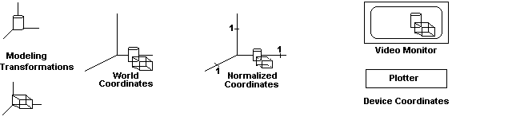

The display hardware divides screen into a number of pixels arranged in a grid with each pixel are associated its x , y coordinates.

Top left corner of screen is called origin of coordinate system

Value of ‘x’ coordinate increases from left to right

Value of ‘y’ coordinate increases from top towards bottom.

These coordinates are reference d to as device for screen coordinates.

For the VGA graphics card the size of display grid is 640 x 480.

Similarly suitable coordinate system can be selected for objective in space

The coordinates so defined are world coordinates

It may sometimes be desirable to select a part of object or drawing for display in order to obtain sufficient detail of the object on display

The part of interest is enclosed n a rectangular boundary called a window

For displaying one has to convert world coordinates into screen coordinates
This transformation is called viewing transformation

In general view transformation consists of operations such as scaling, translation , rotation etc.

Window to View Port Transformation (2-D Viewing Transformation Pipeline)
Construct World coordinate
Scene using modeling-coordinate transformations
Convert world coordinates to viewing coordinates
Map viewing coordinates to normalized viewing coordinates using window view port specifications
Map normalized view port to device coordinates
A point in position(x_{w},y_{w}) in window is mapped into position (x_{v,} y_{v}) in the view port

To maintain same relative placement in view port as in window we require,
x_{v –} x_{vmin =} x_{w –} x_{wmin}
x_{vmax –} x_{vmin} x_{wmax –} x_{wmin}
and,
y_{v –} y_{vmin =} y_{w –} y_{wmin}
y_{vmax –} y_{vmin} y_{wmax –} y_{wmin}

solving equations for view port position (x_{v} , y_{v})

x_{v =} x_{vmin +} (x_{w –} x_{wmin}) (x_{vmax –} x_{vmin}) = x_{vmin +} (x_{w –} x_{wmin}) . s_{x}
(x_{wmax –} x_{wmin})

y_{v =} y_{vmin +} (y_{w –} y_{wmin}) (y_{vmax –} y_{vmin}) = y_{vmin +} (y_{w –} y_{wmin}) . s_{y}
(y_{wmax –} y_{wmin})

where, s_{x} and s_{y} are the scaling factors.

Sequence of Transformations
- Perform scaling transformation using fixed point position(x_{wmin} , y_{wmin}) that scales the window area to the size of the view port
- Translate the scaled window area to the position of the view port
(x_{wmax},y_{wmax}) (x_{vmax},y_{vmax})
(x_{wmin},y_{wmin}) (x_{vmin},y_{vmin})

